Course Code: CSA1557

Course Name: Cloud Computing and Big Data Analytics

R.Kishore 192224280

5) Create a simple cloud software application for car booking using any Cloud Service Provider to demonstrate SaaS include the necessary fields such as login of the user, custom location, the user choosing, id proof, signature etc.

AIMS:

To create a simple cloud software application for car booking System using any Cloud Service Provider to demonstrate SaaS.

PROCEDURE:

Step1: Go to zoho.com.

Step 2: Log into the zoho.com.

Step 3: Select one application step.

Step4: Enter application name as Kipsta car booking system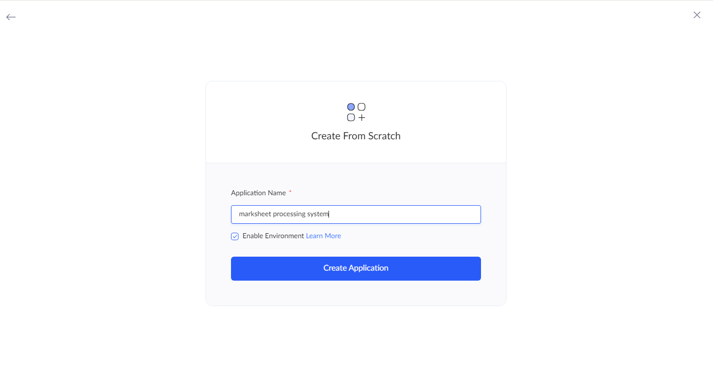.

Step 5: Created new application as car booking system.

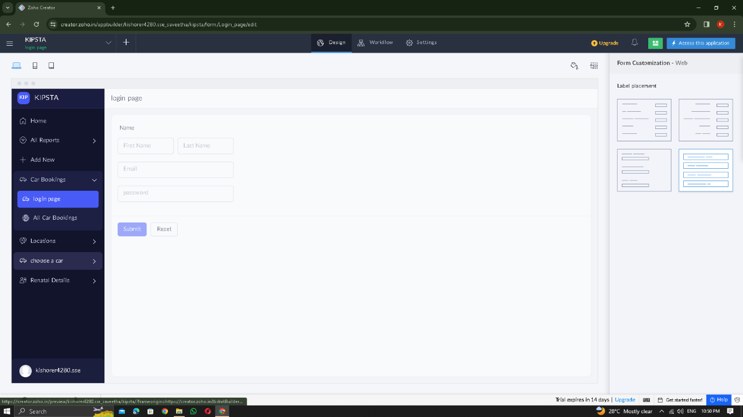

STEP 6: Select from Stratch and Create form as login.

STEP 7: The form has been created as login

Choose the fields.

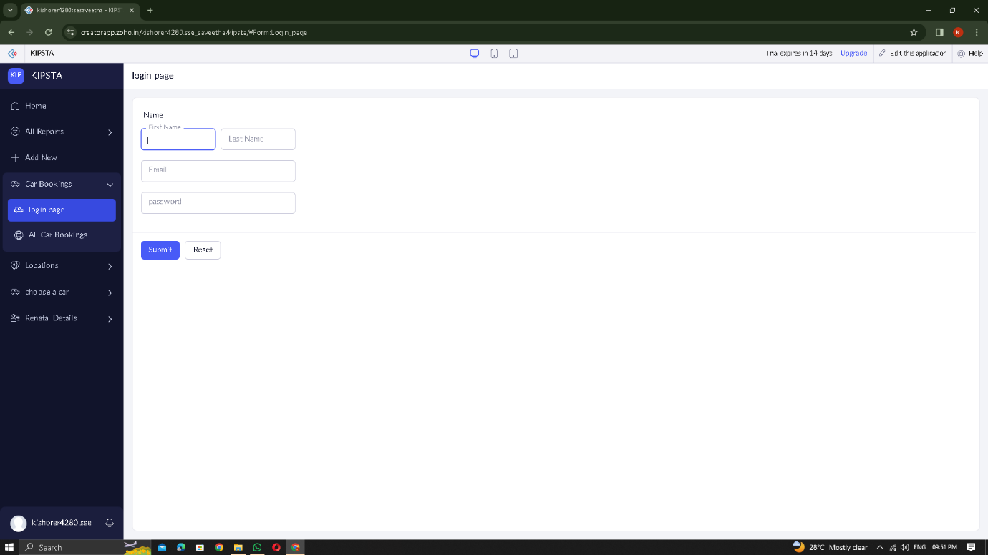

STEP 8: Click Access Development Live

STEP 9: Enter the details of the login.

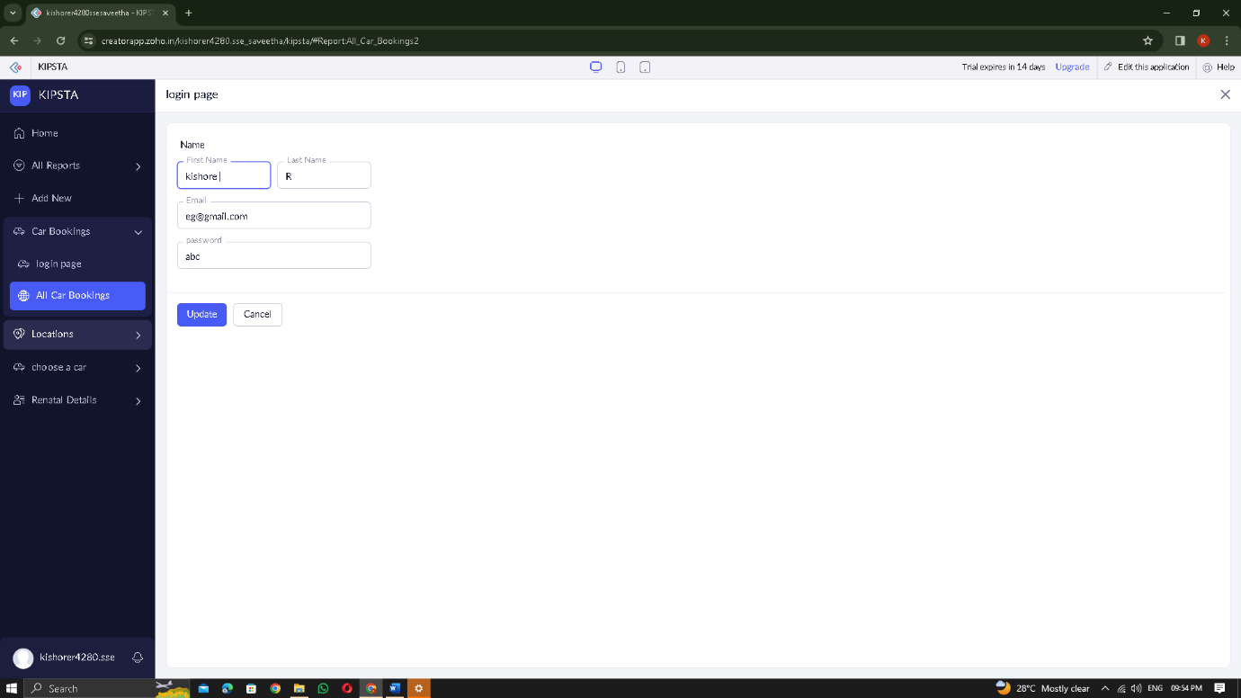

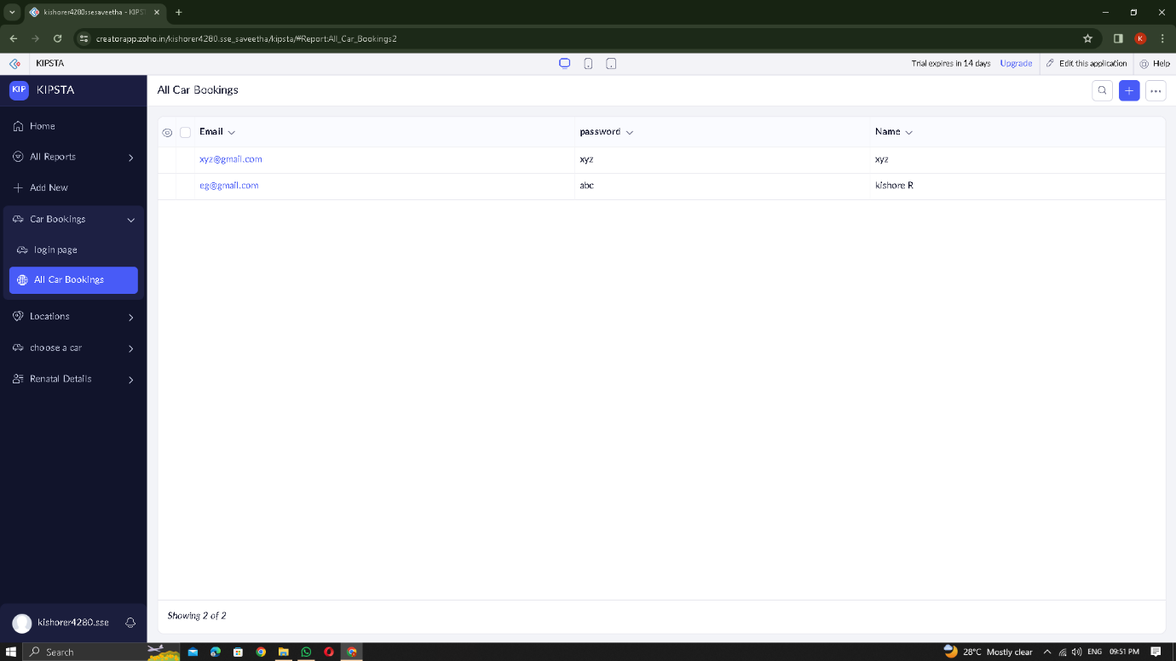

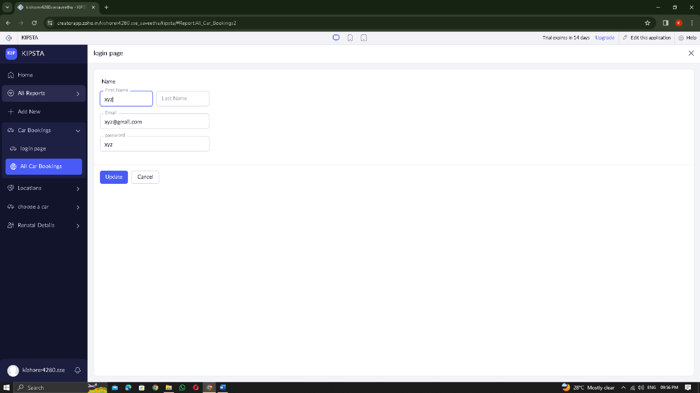

STEP 10: The report has been entered in the login report.

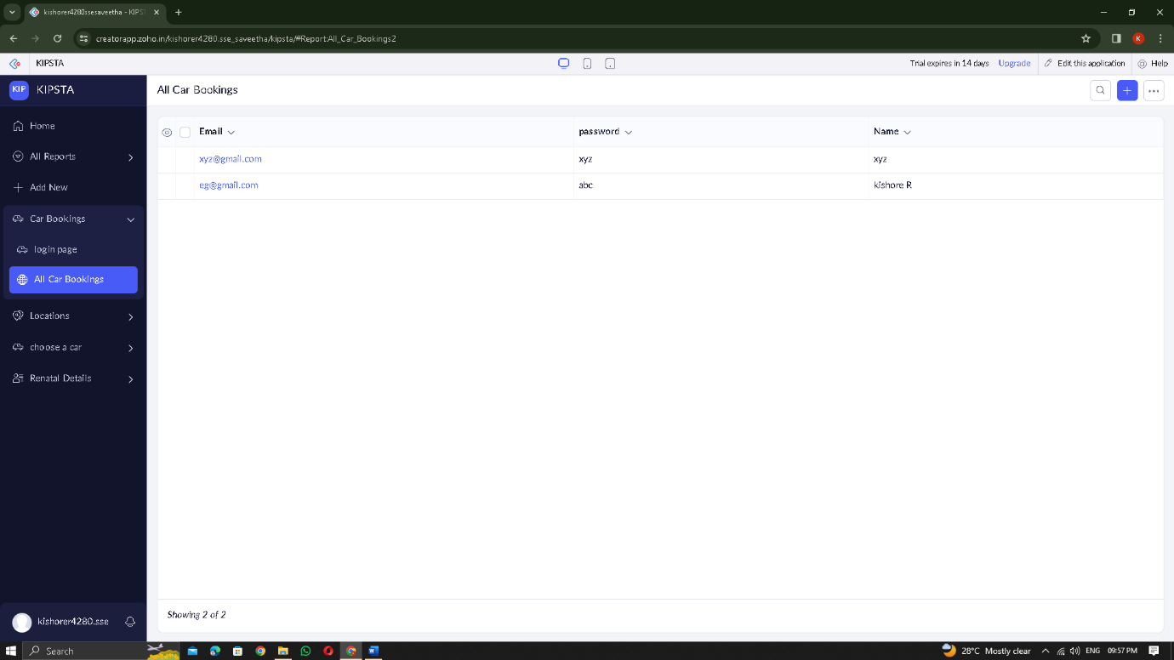

STEP 11: Select from Stratch and Create form as location

STEP 12: The form has been created as location

Choose the fields.

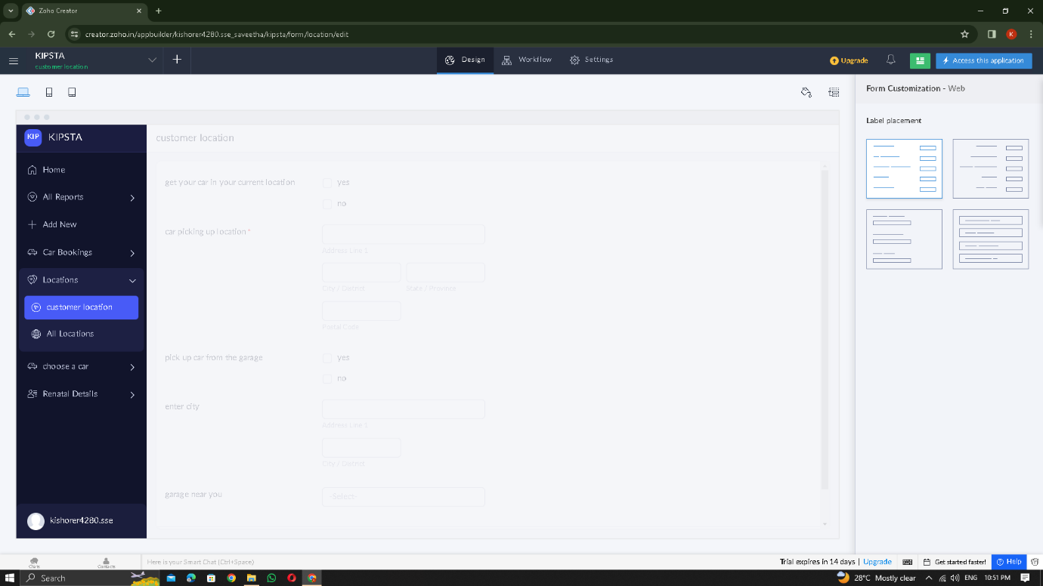

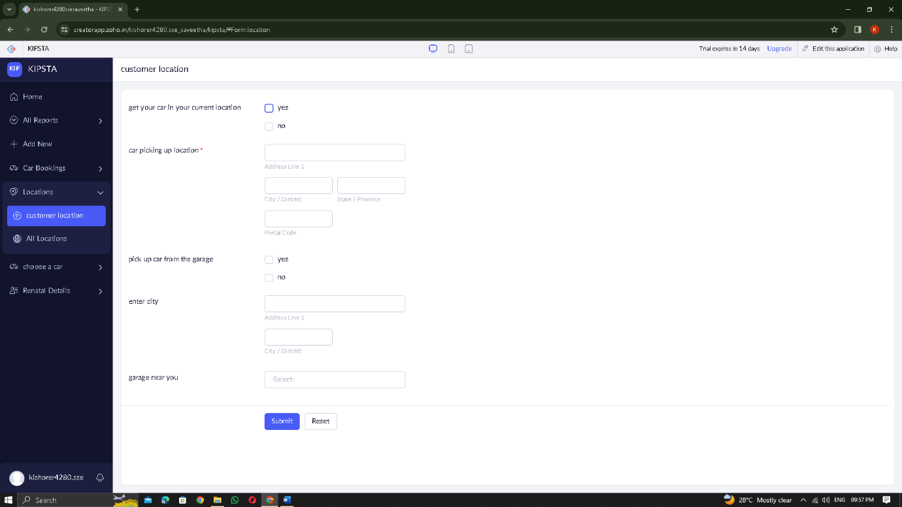

STEP 13: Click Access Development Live

STEP 14: Enter the details of the location of the user.

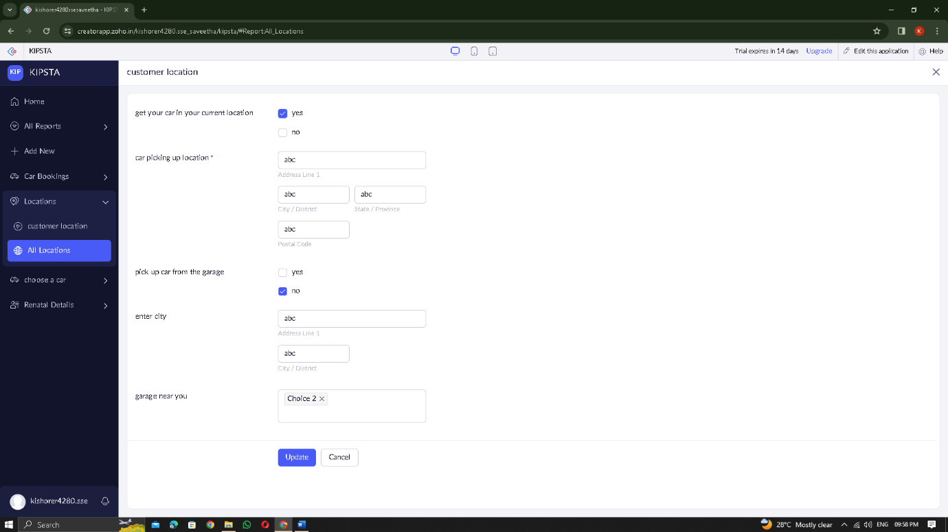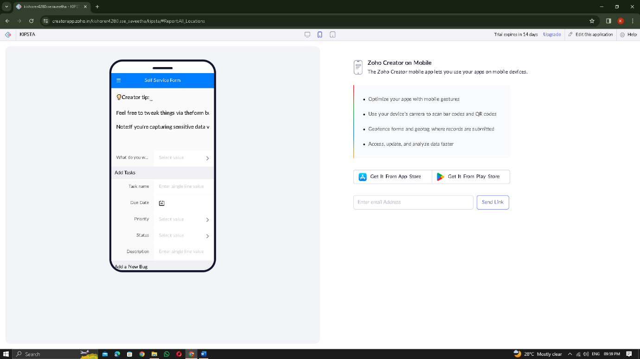

STEP 15: The report has been entered in the login report.

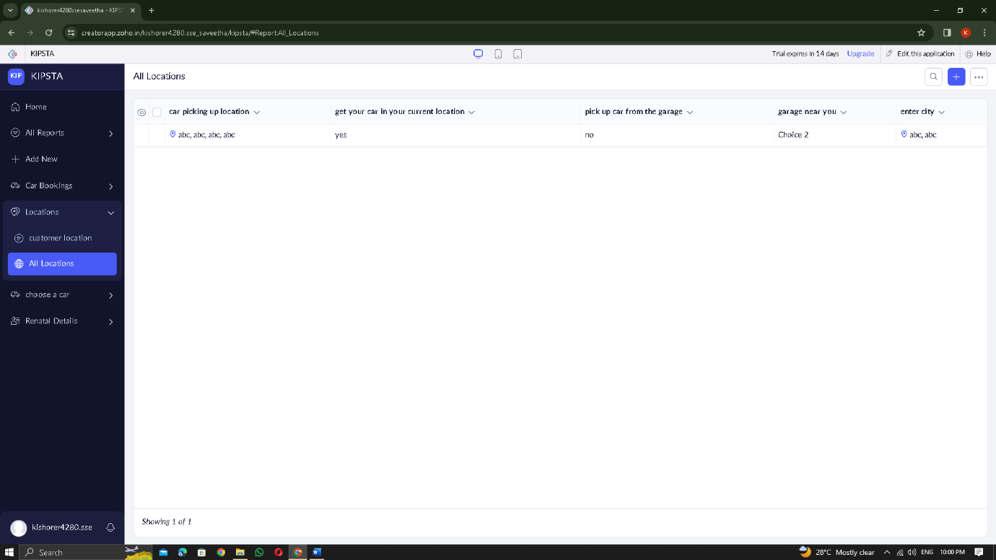

STEP 16: Select from Stratch and Create form as CHOOSING A CAR

STEP 17: The form has been created as CHOOSING CAR

Choose the fields.

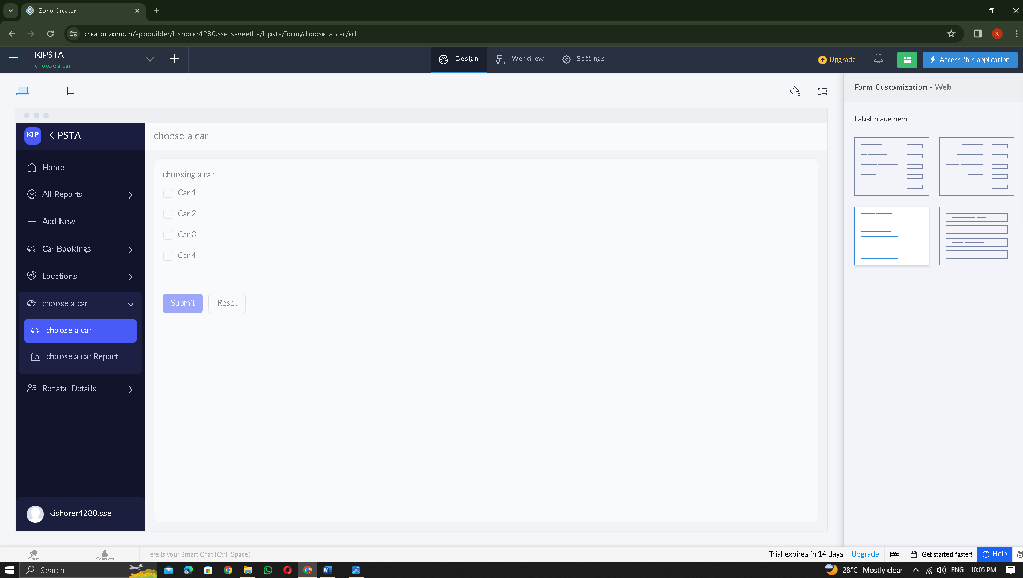

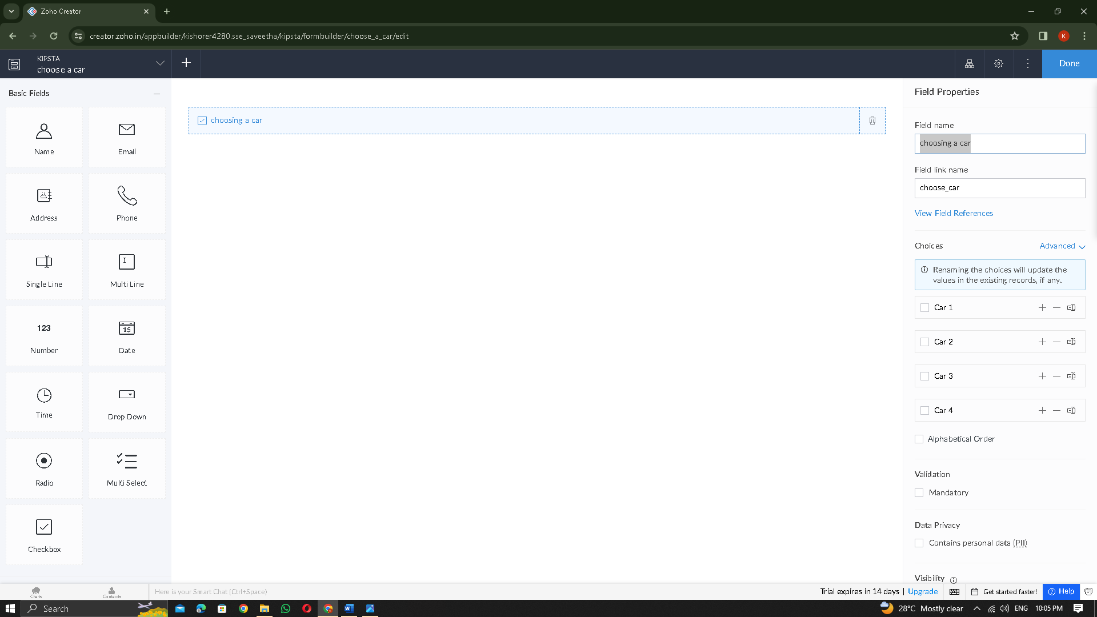

STEP 18: Click Access Development Live

STEP 19: Enter the CAR CHOOSEN BY the user

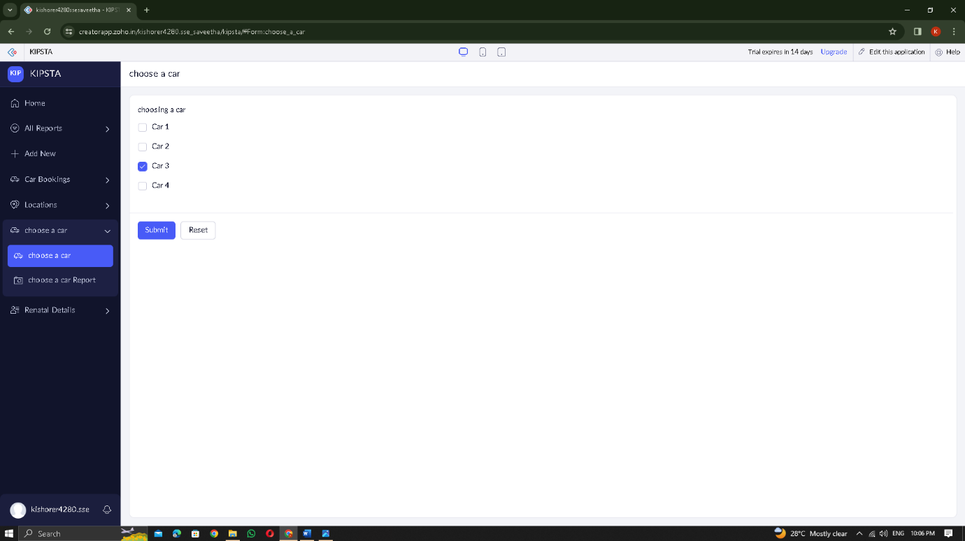

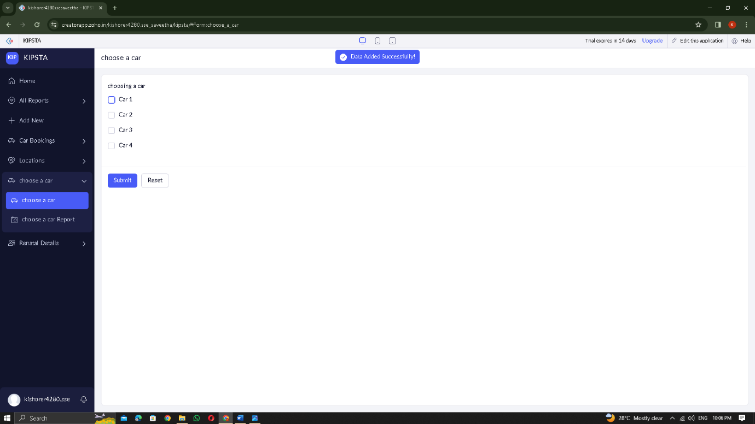.

STEP 20: The report has been entered in the CHOOSING CAR report.

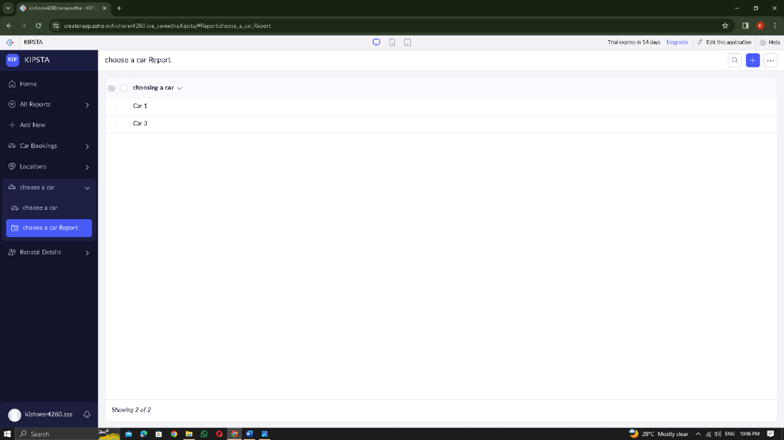

STEP 21: Select from Stratch and Create form as RENTAL SERVICE

STEP 22: The form has been created as RENTAL SERVICE

Choose the fields.

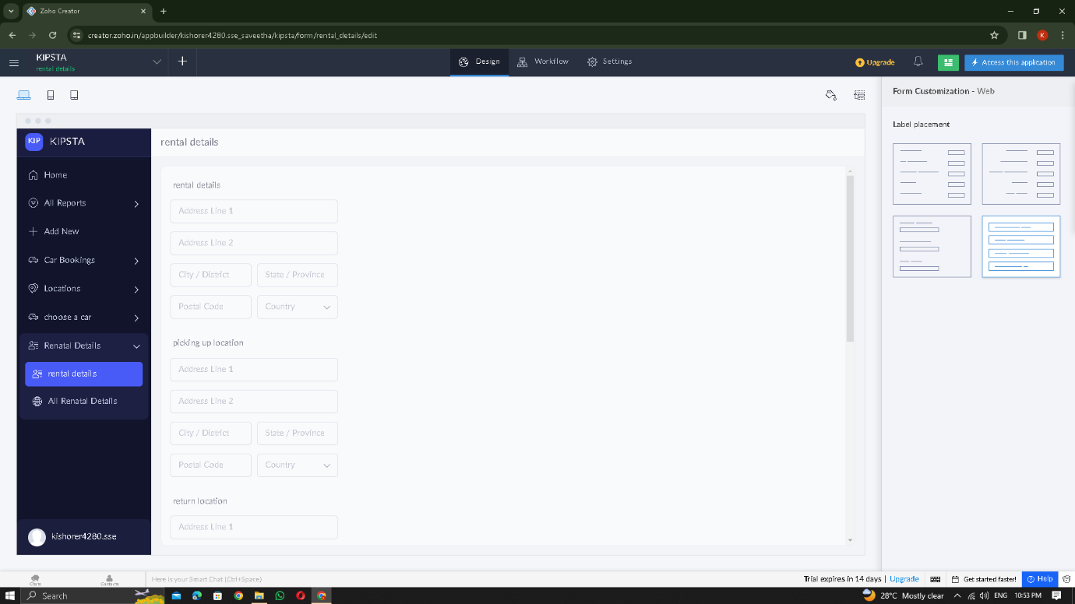

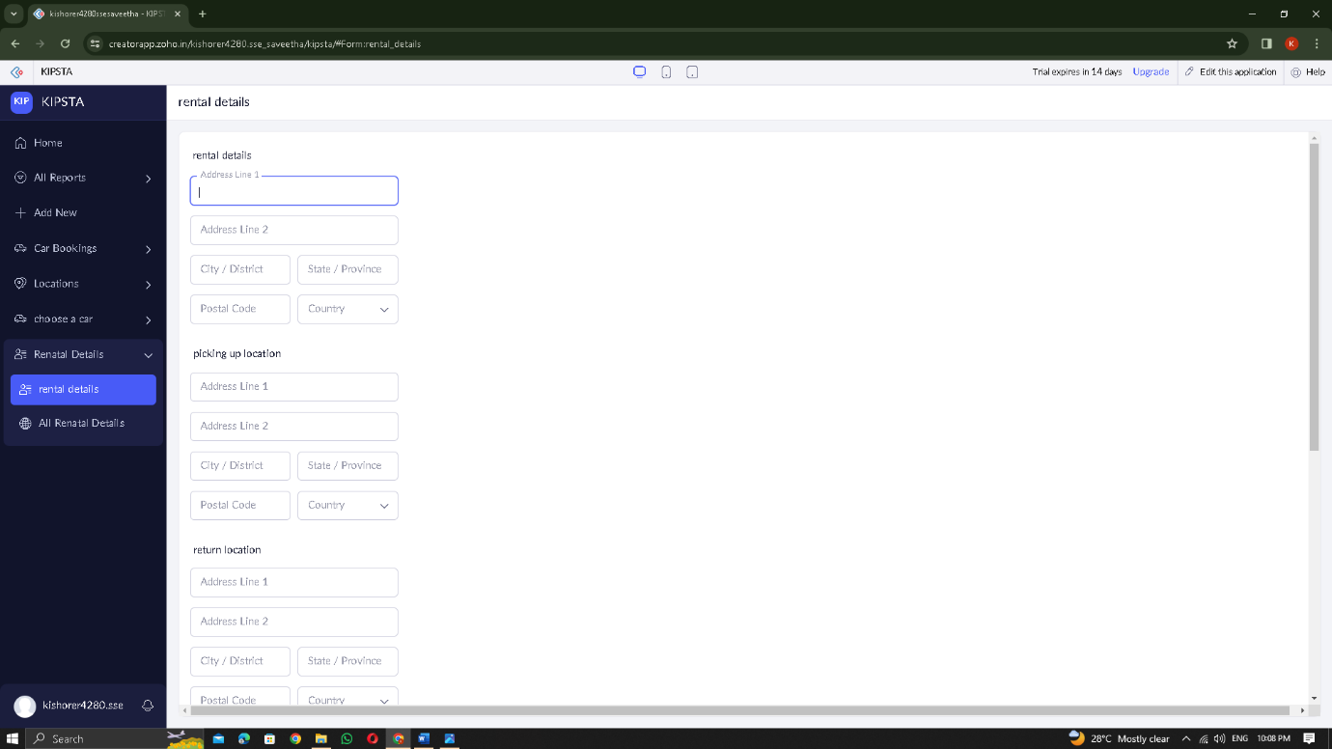

STEP 23: Click Access Development Live

STEP 24: Enter the RENTAL DETAILS of the user

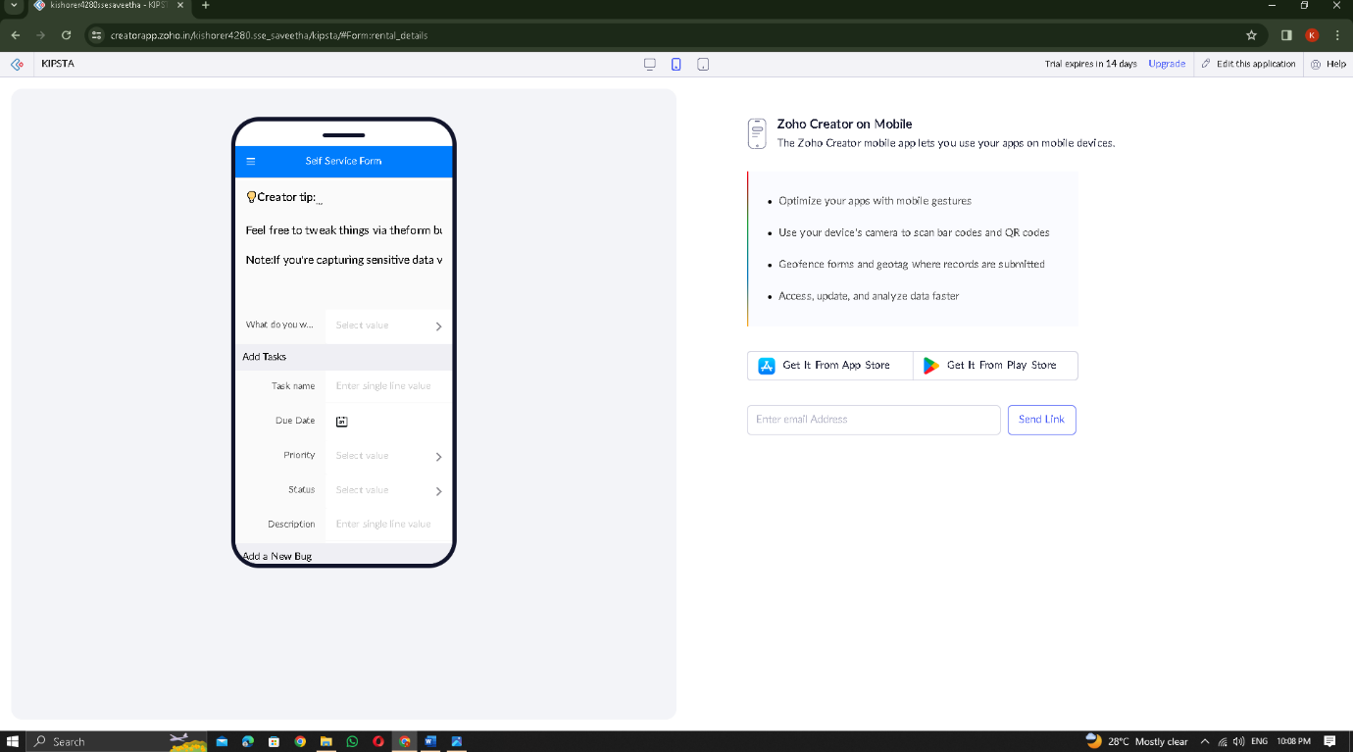

STEP 25: The report has been entered in the RENTAL DETAILS report.

